CSS BRITISH HISTORY · TOPIC 10 · KNOWLEDGE BASE
Blair to Burnham (1997–2026)
Contemporary Britain — New Labour, devolution and the Good Friday Agreement, the War on Terror and Iraq, the financial crisis, the Cameron coalition, Brexit, Covid, five Prime Ministers in eight years, Starmer's landslide and fall, and Andy Burnham's premiership (2026)

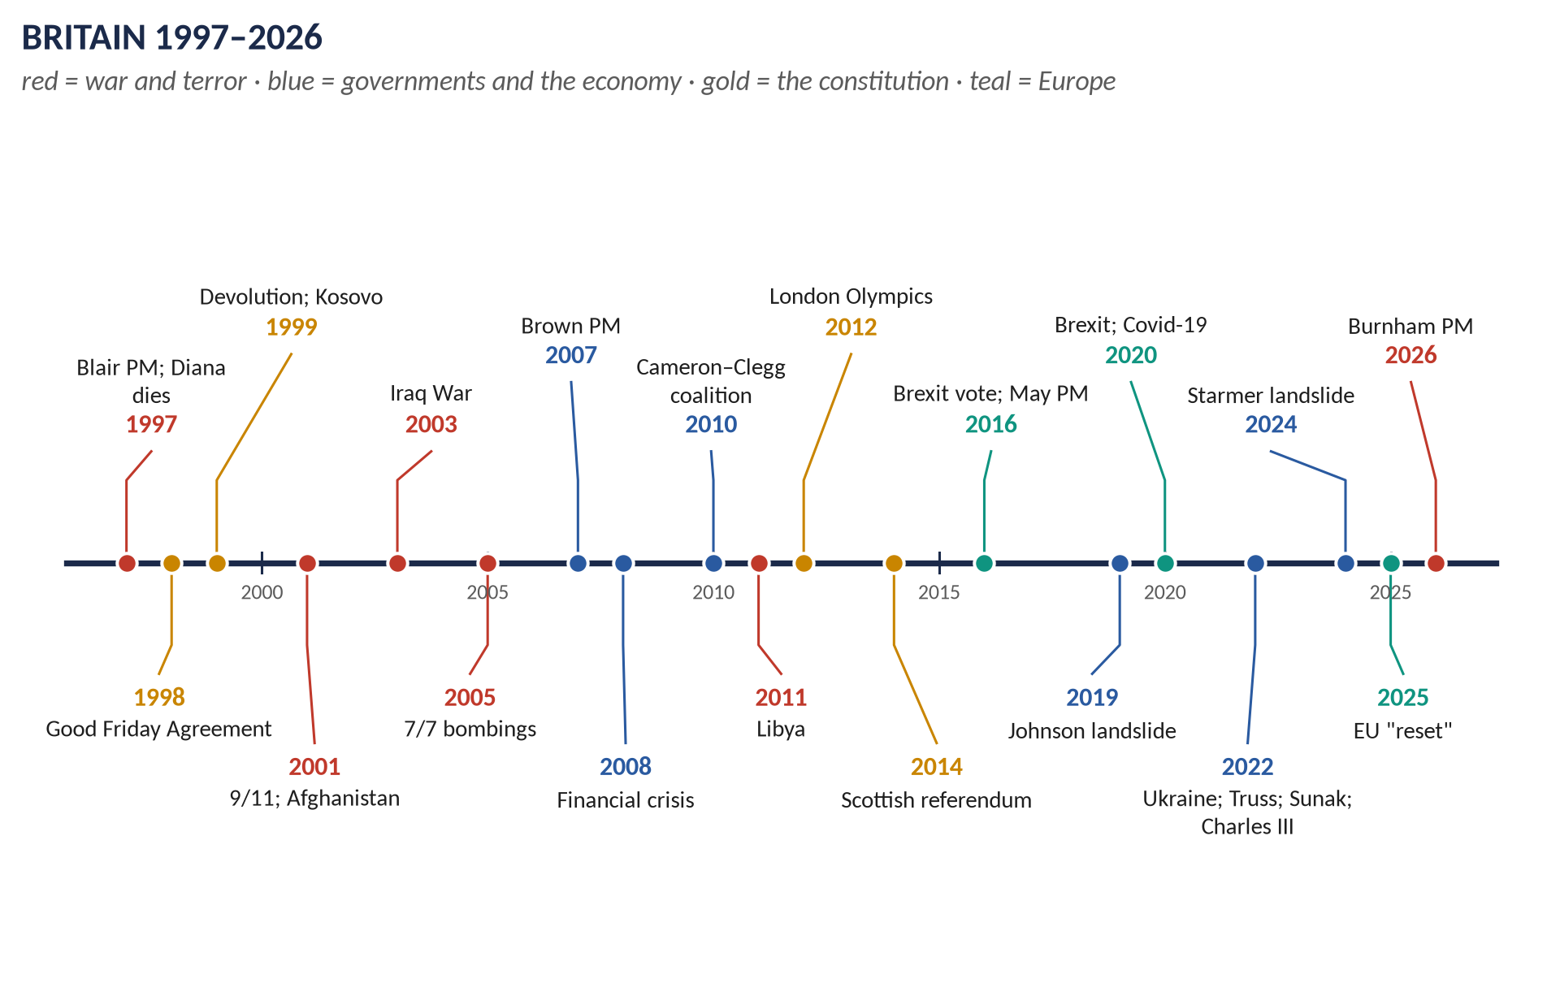
Syllabus head XIV and beyond. 13 past items in 2015–2026 — the War on Terror 3, New Labour 2, the financial crisis 2, Cameron 3, Brexit, Lady Diana 2 — and 8 MCQs. Told from zero, then eight chapters from 1997 to 2026, with 120 one-liners and a stand-alone revision sheet.
Topic 10 of 10 · read with the companion document T10QA
Contents
HOW TO USE THIS · Updating the contents
Right-click the contents → Update Field → Update entire table, before saving as PDF.

How to Use This Document 5
What this Topic covers 5
Part Zero — The ABC Before the Story 6
0.1 The words you need 6
Part One — The Story 7
1.1 New Labour (1997–2007) 7
1.2 The War on Terror (2001–2021) 7
1.3 Brown and the crash (2007–2010) 7
1.4 Cameron and the coalition (2010–2016) 7
1.5 Brexit and turmoil (2016–2024) 7
1.6 Starmer and Burnham (2024–2026) 8
Part Two — The Cast and the Time-line 9
2.1 The cast 9
2.2 The time-line 10
Part Three — The Chapters 11
Chapter 1 · New Labour (1997–2010) 12
1.1 The making of New Labour 12
1.2 Elections 13
1.3 The economy 13
1.4 Social policy 13
1.5 Constitutional reform — the biggest in a century 14
1.6 Foreign policy 14
1.7 Gordon Brown (2007–2010) 15
1.8 New Labour: Old Labour, Thatcherism — or something new? 15
Chapter 2 · The War on Terror 16
2.1 9/11 and the response 16
2.2 Afghanistan (2001–2021) 16
2.3 Iraq (2003–2009) 17
(i) The case for war 17
(ii) Opposition 17
(iii) The war 17
(iv) The Chilcot Report (6 July 2016) 17
2.4 The home front 17
2.5 The effect on British–American relations 18
2.6 A balanced critique 18
Chapter 3 · The Global Financial Crisis and Austerity 19
3.1 How the crisis began 19
3.2 The crisis in Britain 19
3.3 The recession 20
3.4 Two responses compared 20
3.5 The impact on politics and society 20
3.6 Long-term effects 20
Chapter 4 · David Cameron (2010–2016) 22
4.1 The coalition 22
4.2 Reforms under Cameron 22
(i) Economy and welfare 22
(ii) Education 23
(iii) Health 23
(iv) Society 23
(v) The constitution 23
4.3 Cameron's foreign policy 23
(i) General features 23
(ii) The Middle East 24
Chapter 5 · Brexit (2016–2026) 26
5.1 The road to the referendum 26
5.2 The referendum (23 June 2016) 26
5.3 Leaving (2016–2020) 26
5.4 Advantages and disadvantages — the arguments and the evidence 27
5.5 Public opinion and the "reset" 27
Chapter 6 · Lady Diana (1961–1997) 28
Chapter 7 · Britain since 2016 29
7.1 May, Johnson, Truss, Sunak 29
7.2 Starmer (2024–2026) and Burnham (2026–) 29
Chapter 8 · 1997–2012: Renewal or Unresolved Contradictions? 31
Part Four — Historians and Quotations 32
Part Five — The Examiner's Record 33
Part Six — The One-Liner Bank 35
One-liners · New Labour 35
One-liners · The War on Terror 36
One-liners · The financial crisis 37
One-liners · Cameron 37
One-liners · Brexit and after 38
One-liners · Diana 39
Part Seven — Revision Sheet · Topic 10: Blair to Burnham 40
R10.1 New Labour 40
R10.2 The War on Terror 40
R10.3 The financial crisis 40
R10.4 Cameron 41
R10.5 Brexit 41
R10.6 Diana 41
R10.7 Since 2016 and the big question 41

How to Use This Document

What this Topic covers
Topic 10 is contemporary Britain, from Tony Blair's victory in 1997 through Keir Starmer's government (2024–26) to Andy Burnham, Prime Minister from July 2026. The syllabus officially stops in 2012, but the examiner has asked about Brexit, the financial crisis and David Cameron, and the MCQs test events to 2010 and beyond — so this Knowledge Base carries the story to the present.
WHAT THE EXAMINER HAS ASKED · Why this topic matters
13 items in 2015–2026 and 8 MCQs — and growing fast (three full questions and three short notes in 2025–26 alone). The War on Terror (2021, 2023, 2026 sn), New Labour (2025, 2026), the financial crisis (2023, 2025), Cameron (2016; reforms sn 2024, 2025), Brexit (2017) and Lady Diana (sn 2018, 2026).

THE STORY IN SIMPLE WORDS · Where this topic fits in the story
Topic 9 ended with the Conservatives' crushing defeat in 1997 after eighteen years in power. Topic 10 is the story of the four decades that followed — New Labour's thirteen years, the Conservatives' fourteen years (2010–24), and Labour's return.

Part Zero — The ABC Before the Story

0.1 The words you need
Word | What it means, simply
New Labour | Tony Blair's modernised Labour Party (from 1994–97): accepting markets while investing in public services.
Third Way | New Labour's idea of a path between old socialism and free-market Thatcherism.
Devolution | Handing powers from London to elected bodies in Scotland, Wales and Northern Ireland.
Good Friday Agreement | The 1998 peace agreement for Northern Ireland.
War on Terror | The US-led campaign against terrorism after the attacks of 11 September 2001 ("9/11").
WMD | Weapons of mass destruction — chemical, biological or nuclear.
Financial crisis | The banking collapse of 2007–09 that caused a world recession.
Recession | A fall in national output (GDP) for at least two quarters in a row.
Austerity | Cutting public spending (and raising some taxes) to reduce government borrowing.
Quantitative easing (QE) | The Bank of England creating money to buy bonds, to push down interest rates and support the economy.
Coalition | A government of two or more parties — the Conservatives and Liberal Democrats, 2010–15.
Referendum | A national vote on a single question.
Brexit | Britain's exit from the European Union (voted 2016, left 2020).
Populism | Politics that sets "the people" against "the elite".

KEY IDEA · The one idea to hold on to
Blair's New Labour tried to combine a market economy with social justice and a modernised constitution, and made Britain America's closest ally in the War on Terror. The financial crisis of 2008 ended the long boom that had paid for its plans, brought a decade of austerity, and fed the anger that produced Brexit — the defining event of the century so far.

Part One — The Story

1.1 New Labour (1997–2007)
On 1 May 1997 Tony Blair won a landslide (418 seats). New Labour gave the Bank of England independence, introduced a minimum wage, poured money into the NHS and schools, created a Scottish Parliament and Welsh Assembly, passed the Human Rights Act, and helped bring peace to Northern Ireland (the Good Friday Agreement, 1998). Months after Blair took office, Diana, Princess of Wales, died in a car crash in Paris; Blair called her "the People's Princess". Blair won again in 2001 and 2005.

1.2 The War on Terror (2001–2021)
After terrorists attacked the USA on 11 September 2001, Blair promised to stand "shoulder to shoulder" with America. British forces helped overthrow the Taliban in Afghanistan (2001) and joined the US invasion of Iraq (2003) — a war that split the country, because the weapons of mass destruction Blair had warned of were never found. In July 2005 suicide bombers killed 52 people in London (7/7).

1.3 Brown and the crash (2007–2010)
Gordon Brown replaced Blair in 2007. Within months the global financial crisis struck: Northern Rock collapsed, and in October 2008 the government had to rescue the great banks. Britain fell into its deepest recession since the 1930s. In 2010 no party won a majority.

1.4 Cameron and the coalition (2010–2016)
David Cameron's Conservatives formed a coalition with Nick Clegg's Liberal Democrats. They cut spending (austerity), reformed welfare and schools, legalised same-sex marriage, and intervened in Libya (2011). Scotland voted to stay in the UK (2014). Cameron won a majority in 2015 and held a referendum on the EU; on 23 June 2016 Britain voted to leave.

1.5 Brexit and turmoil (2016–2024)
Theresa May could not get her Brexit deal through Parliament; Boris Johnson won a large majority in December 2019 and took Britain out of the EU on 31 January 2020. Then came the Covid-19 pandemic (2020–22), scandals ("partygate"), Liz Truss's 49-day premiership (2022), and Rishi Sunak. In September 2022 Queen Elizabeth II died after 70 years; Charles III became King.

1.6 Starmer and Burnham (2024–2026)
On 4 July 2024 Keir Starmer's Labour won 411 seats. His government promised growth and renewal, sought a "reset" with the EU (2025), and supported Ukraine, while facing a weak economy and the rise of Reform UK. After disastrous May 2026 elections — Labour lost about 1,500 councillors, Plaid Cymru took power in Wales and Reform UK became the opposition there — Starmer's party turned on him. Andy Burnham, Mayor of Greater Manchester, returned to Parliament at the Makerfield by-election (18 June 2026); Starmer announced his resignation (22 June), and Burnham, elected Labour leader unopposed, became Prime Minister on 20 July 2026.
VERDICT · The story in one sentence
From 1997 to 2026 Britain moved from New Labour's confident renewal, through the War on Terror and the financial crash, to austerity, Brexit and political turmoil — ending with Labour back in power in an anxious, divided country, where even a landslide government lasted only two years under its first leader.

Part Two — The Cast and the Time-line

2.1 The cast
Person | Office | Who they were — in one line
Tony Blair | PM 1997–2007 | Created New Labour; three election wins; Iraq.
Gordon Brown | Chancellor 1997–2007; PM 2007–10 | The long boom; the financial-crisis rescue.
Robin Cook | Foreign Sec. 1997–2001 | "Ethical dimension"; resigned over Iraq (2003).
Diana, Princess of Wales | 1961–97 | "The People's Princess"; died 31 August 1997.
George W. Bush | US President 2001–09 | Led the War on Terror.
David Cameron | PM 2010–16 | Coalition; austerity; the EU referendum.
Nick Clegg | Deputy PM 2010–15 | Liberal Democrat leader in the coalition.
George Osborne | Chancellor 2010–16 | Austerity.
Theresa May | PM 2016–19 | Brexit negotiations.
Boris Johnson | PM 2019–22 | "Get Brexit done"; Covid; partygate.
Liz Truss | PM Sept–Oct 2022 | The shortest-serving PM.
Rishi Sunak | PM 2022–24 | First British Asian PM.
Keir Starmer | PM 2024–26 | Labour's landslide; resigned after the May 2026 elections.
Andy Burnham | PM from July 2026 | Former Mayor of Greater Manchester; returned to Parliament for Makerfield (June 2026).
Charles III | King from 2022 | Succeeded Elizabeth II.

2.2 The time-line
Figure 1 · Britain 1997–2026.

Part Three — The Chapters

Chapter 1 · New Labour (1997–2010)
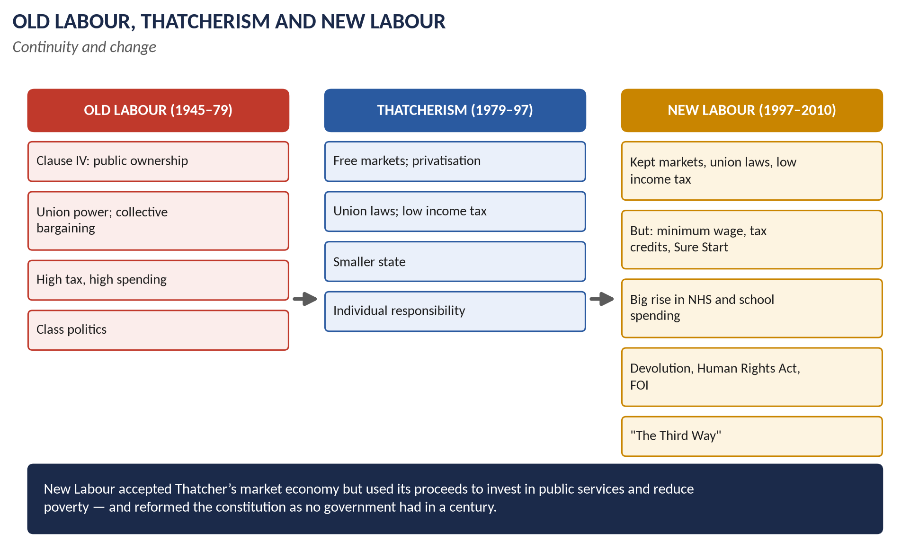
Figure 2 · Old Labour, Thatcherism and New Labour.

1.1 The making of New Labour
- Four defeats (1979, 1983, 1987, 1992) convinced Labour's modernisers that the party had to change.
- Neil Kinnock (1983–92) expelled the Militant Tendency and dropped unilateral disarmament; John Smith (1992–94) introduced "one member, one vote".
- Tony Blair (leader from July 1994) rewrote Clause IV (1995): public ownership replaced by "a dynamic economy … the enterprise of the market and the rigour of competition … with a just society".
- The "Third Way" (sociologist Anthony Giddens, 1998): between old state socialism and free-market neo-liberalism.
- Slogans: "Education, education, education"; "tough on crime, tough on the causes of crime"; "New Labour, New Britain".

1.2 Elections
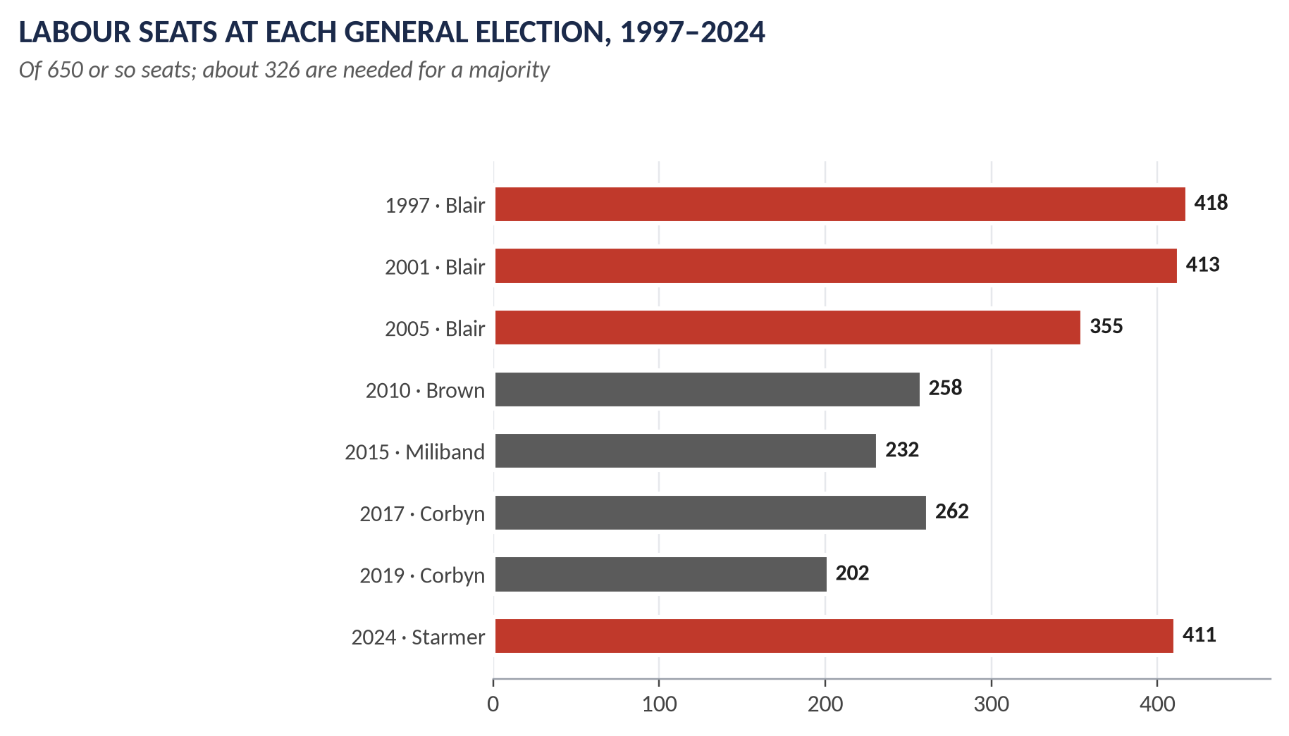
Figure 3 · Labour seats, 1997–2024.
Election | Labour seats | Majority
1 May 1997 | 418 | 179
7 June 2001 | 413 | 167
5 May 2005 | 355 | 66

1.3 The economy
- Bank of England independence (May 1997): the Bank set interest rates to meet an inflation target.
- Gordon Brown's "prudence": two years within Conservative spending limits; "no return to boom and bust".
- Low income tax kept (basic rate cut to 22p, then 20p in 2008); a windfall tax on privatised utilities paid for the New Deal for young unemployed.
- The long boom: steady growth until 2007; employment rose.
- But: light-touch regulation of the City (the Financial Services Authority, 1997); rising household and public debt; PFI (private finance for hospitals and schools) stored up costs.

1.4 Social policy
- The National Minimum Wage (April 1999, £3.60 an hour) — opposed by the Conservatives, now accepted by all.
- Tax credits (Working Families Tax Credit, 1999; Child Tax Credit, 2003); the Winter Fuel Payment.
- Child poverty: a pledge (1999) to halve it by 2010 and end it by 2020 — it fell by about 600,000 children by 2010, short of the target.
- Sure Start (1998): children's centres for families in poor areas.
- Health: NHS spending roughly doubled in real terms (1997–2010); waiting times fell sharply; but targets and PFI were criticised.
- Education: literacy and numeracy hours; academies (2000); more teachers; tuition fees (1998, £1,000; "top-up" fees to £3,000 in 2004); 50 per cent university target.
- Crime: more police; ASBOs (1998).
- Social liberalism: civil partnerships (2004); equalised age of consent (2000); the fox-hunting ban (2004); the Equality Act (2010).

1.5 Constitutional reform — the biggest in a century
1. Devolution: referendums (September 1997); the Scottish Parliament and Welsh Assembly opened in 1999; the Northern Ireland Assembly (1998); a Mayor of London (2000).
2. The Good Friday Agreement (10 April 1998): power-sharing in Northern Ireland between unionists and nationalists; the Irish Republic dropped its territorial claim; a united Ireland only by majority consent; prisoners released; confirmed by referendums in both parts of Ireland (May 1998). Blair, Bertie Ahern, US Senator George Mitchell, David Trimble and John Hume (Nobel Prize 1998).
3. The Human Rights Act (1998, in force 2000): the European Convention on Human Rights made part of UK law.
4. The House of Lords Act (1999): most hereditary peers removed (92 kept).
5. The Freedom of Information Act (2000, in force 2005).
6. The Constitutional Reform Act (2005): a Supreme Court (opened 2009) replaced the Law Lords.
7. Bank of England independence (1997).

1.6 Foreign policy
- "An ethical dimension" (Robin Cook, 1997).
- Kosovo (1999): NATO bombing to stop Serbian ethnic cleansing; Blair's Chicago speech (April 1999) set out the "doctrine of the international community" — intervention to stop humanitarian disasters.
- Sierra Leone (2000): a British force saved the capital from rebels (Operation Palliser).
- The Department for International Development (1997); aid doubled; debt relief; the Gleneagles G8 (2005) on Africa and climate.
- Europe: signed the Social Chapter (1997); St Malo (1998) on European defence; stayed out of the euro.
- The War on Terror and Iraq — Chapter 2.

1.7 Gordon Brown (2007–2010)
- Became PM in June 2007 unopposed; dithered over an early election (autumn 2007).
- The financial crisis (Chapter 3); the Climate Change Act (2008) — the world's first legally binding carbon target.
- The MPs' expenses scandal (May 2009).
- The 2010 election: a hung parliament (Conservatives 306, Labour 258, Liberal Democrats 57).

1.8 New Labour: Old Labour, Thatcherism — or something new?
Area | Old Labour (1945–79) | Thatcherism (1979–97) | New Labour (1997–2010)
Ownership | Nationalisation (Clause IV) | Privatisation | Kept privatisation; PFI
Unions | Partners in government | Curbed by law | Laws kept; unions at arm's length
Tax | High, redistributive | Low income tax | Low income tax; "redistribution by stealth"
Spending | High | Restrained | Big rises for NHS and schools
Poverty | Welfare state | Less priority | Minimum wage, tax credits, Sure Start
Constitution | Little change | Centralisation | Devolution, HRA, FOI, Lords
Voters | Working class | Aspiring middle class | "Big tent": both

- "Thatcherism by other means"? — Stuart Hall called New Labour "the great moving nowhere show" (1998); Thatcher reportedly called New Labour her "greatest achievement" (2002).
- A distinct project? — its investment in public services, attack on poverty and constitutional revolution went far beyond anything Thatcher would have done.
- Verdict: a distinct project built on Thatcherite foundations.
WHAT THE EXAMINER HAS ASKED · Where Chapter 1 has been asked
2025 Q6 (New Labour v previous Labour governments; Thatcherism or a distinct project?) · 2026 Q7 (1997–2012: renewal or contradictions?). MCQs 2025: Blair led the Labour Party; 2026: the Good Friday Agreement addressed Northern Ireland.

Chapter 2 · The War on Terror
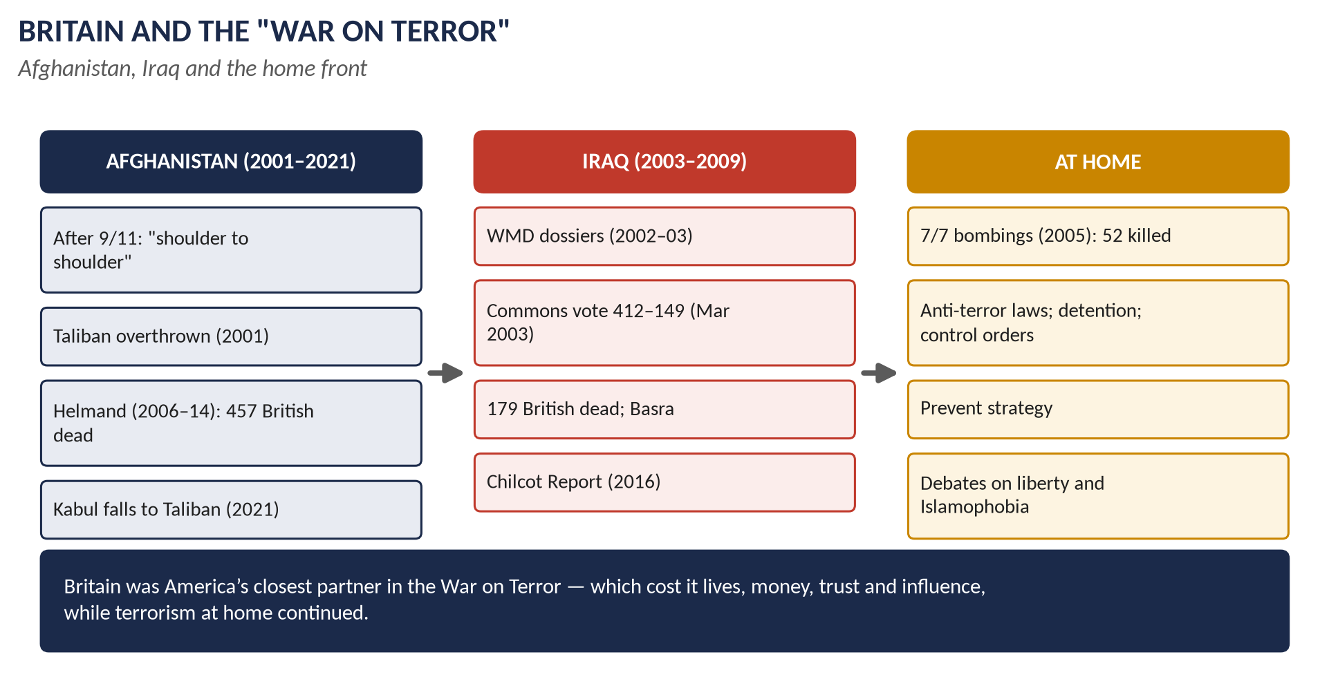
Figure 4 · Britain and the War on Terror.

2.1 9/11 and the response
- 11 September 2001: al-Qaeda terrorists hijacked four airliners and attacked the World Trade Center and the Pentagon; about 3,000 killed, including 67 Britons.
- President George W. Bush declared a "War on Terror". On 15 September he said: "We will find those who did it, we will smoke them out of their holes, we will get them running and we will bring them to justice."
- Blair: Britain would stand "shoulder to shoulder" with America; he became the chief international advocate of the campaign.

2.2 Afghanistan (2001–2021)
- October 2001: US and British forces attacked the Taliban government, which sheltered Osama bin Laden; Kabul fell in November.
- ISAF (NATO) from 2001; British forces took over Helmand province (2006) — heavy fighting (Camp Bastion; Sangin).
- British combat operations ended in October 2014; 457 British servicemen died.
- August 2021: after the US withdrawal, the Taliban retook Kabul; Britain evacuated about 15,000 people (Operation Pitting).
- Bin Laden was killed by US forces in Pakistan (May 2011).

2.3 Iraq (2003–2009)

(i) The case for war
- Saddam Hussein was said to possess weapons of mass destruction and to defy UN resolutions; the "axis of evil" (Bush, 2002).
- The September Dossier (2002) claimed Iraq could deploy WMD "within 45 minutes"; the "dodgy dossier" (February 2003) was partly copied from a student thesis.
- UN Resolution 1441 (November 2002) gave Iraq a "final opportunity"; Blair failed to get a second resolution.

(ii) Opposition
- About 1 million marched in London (15 February 2003).
- The Commons vote (18 March 2003): 412 to 149 for war — 139 Labour MPs rebelled; Robin Cook resigned.
- France, Germany and Russia opposed the war.

(iii) The war
- 20 March 2003: the invasion; about 46,000 British troops; Basra taken; Saddam fell in April.
- No WMD were found.
- Insurgency and sectarian civil war; British forces in Basra until 2009; 179 British deaths; Iraqi deaths estimated in the hundreds of thousands.
- Dr David Kelly, a weapons expert and BBC source, died (July 2003); the Hutton Report (2004) cleared the government; the Butler Review (2004) criticised the intelligence.

(iv) The Chilcot Report (6 July 2016)
Found that Britain went to war before peaceful options were exhausted, that the WMD threat was presented with unjustified certainty, that planning for the aftermath was "wholly inadequate", and published Blair's note to Bush (July 2002): "I will be with you, whatever."

2.4 The home front
- Terrorism laws: the Terrorism Act (2000); the Anti-terrorism, Crime and Security Act (2001) allowed indefinite detention of foreign suspects without trial (Belmarsh) — ruled incompatible with human rights by the Law Lords (2004); control orders (2005); Blair's first Commons defeat: 90-day detention rejected (November 2005) — 28 days allowed.
- 7/7 (7 July 2005): four British-born suicide bombers attacked three Underground trains and a bus; 52 killed.
- Prevent (from 2006–07): a strategy to stop radicalisation — criticised for targeting Muslims.
- Later attacks: Lee Rigby (2013); Westminster, Manchester Arena and London Bridge (2017).
- Controversies: complicity in rendition and torture (the Libya case, the 2018 Intelligence and Security Committee reports); Guantánamo.

2.5 The effect on British–American relations
- Closer: Blair and Bush had the closest partnership since Churchill and Roosevelt; intelligence and military integration deepened.
- British influence: Blair persuaded Bush to go to the UN (1441) and to launch the Middle East "road map" (2003); he saw himself as the "bridge" between America and Europe.
- Costs: Blair was mocked as "Bush's poodle"; the bridge to Europe broke (France and Germany); British public trust in the relationship fell.
- Afterwards: Brown and Cameron were more cautious; Obama spoke of an "essential relationship"; the Commons refused Syria strikes (2013) — the "Iraq syndrome".

2.6 A balanced critique
Achievements | Failures and costs
Al-Qaeda's Afghan base destroyed; bin Laden killed (2011) | Iraq invaded on false WMD claims; legality disputed
Many plots foiled; no repeat of 9/11 on its scale | Hundreds of thousands of Iraqi and Afghan deaths
International cooperation on intelligence and finance | Chaos in Iraq helped create ISIS (2014)
Some democratic progress in Afghanistan (2001–21) | The Taliban returned (2021)
 | Torture, rendition, detention without trial damaged the West's values
 | Terrorism in Britain increased (7/7, 2017)

WHAT THE EXAMINER HAS ASKED · Where Chapter 2 has been asked
2021 Q8 (Blair's War on Terror; US–British relations) · 2023 Q7 (a balanced critique, with Bush's words) · 2026 Q8(a) (short note). MCQs 2024: Iraq 2003 → Tony Blair; 2026: 7/7 was in 2005.

Chapter 3 · The Global Financial Crisis and Austerity
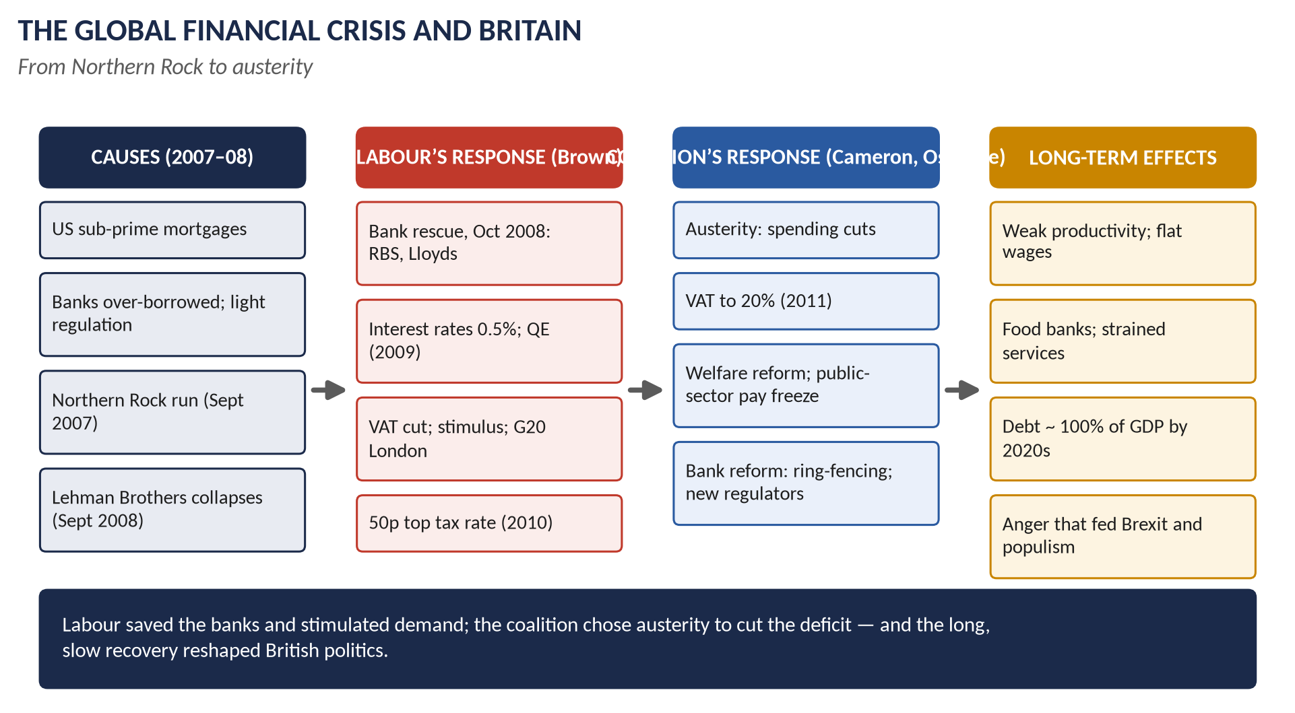
Figure 5 · The financial crisis and Britain.

3.1 How the crisis began
- The US housing bubble: banks lent to "sub-prime" borrowers who could not repay; the loans were packaged into complex securities and sold worldwide.
- British banks had grown enormously — their assets were over four times the size of the economy — and borrowed heavily on the money markets.
- Light-touch regulation: the Financial Services Authority failed to see the risks.

3.2 The crisis in Britain
Date | Event
Sept 2007 | Northern Rock asked the Bank of England for help; savers queued outside — the first bank run in Britain for about 150 years. Nationalised February 2008.
Sept 2008 | Lehman Brothers collapsed in New York (15 September); HBOS was rescued by Lloyds; Bradford & Bingley nationalised.
8 Oct 2008 | The bank rescue: about £500 billion of guarantees, loans and capital; the state took large stakes in RBS (eventually about 84 per cent) and Lloyds (about 43 per cent).
Oct–Dec 2008 | Interest rates cut; VAT cut from 17.5 to 15 per cent (December 2008 – 2010); car scrappage scheme.
Mar 2009 | Bank Rate cut to 0.5 per cent; quantitative easing began (£75 billion, rising to £375 billion by 2012).
Apr 2009 | The G20 London summit: about $1 trillion for the IMF and world economy — Brown's leadership was widely praised.

3.3 The recession
- GDP fell by about 6 per cent (2008–09) — the deepest recession since the Second World War.
- Unemployment rose to about 2.5 million (2009) and peaked at about 2.7 million (2011).
- Government borrowing soared to about 10 per cent of GDP (2009–10); debt rose from about 40 to over 80 per cent of GDP.
- House prices fell; lending dried up (the "credit crunch").

3.4 Two responses compared
 | Labour (Brown and Darling, 2008–10) | Conservative-led coalition (Cameron and Osborne, 2010–16)
Philosophy | Keynesian: support demand; borrow in a slump | Fiscal consolidation: cut the deficit to restore confidence
Banks | Rescue and part-nationalisation | Reform: ring-fencing (Vickers, 2011; Banking Reform Act 2013); FSA replaced by the PRA and FCA (2013); a bank levy
Tax | VAT cut; 50p top rate (2010) | VAT to 20 per cent (2011); 50p cut to 45p (2013); tax-free allowance raised
Spending | Maintained or increased | Deep cuts to departments, local government and welfare
Welfare | Protected | Benefit cap; freezes; Universal Credit
Aim | Protect jobs and output | Eliminate the deficit (target missed several times)

3.5 The impact on politics and society
- Politics: Labour's defeat (2010); the first coalition since 1945; the MPs' expenses scandal (2009) deepened distrust; the Occupy protests (2011); student protests over tuition fees (2010); the 2011 riots; the rise of UKIP; the Scottish independence campaign; the Brexit vote (2016) — research found austerity increased support for Leave.
- Society: wage stagnation — real wages did not return to their 2008 level for over a decade; food banks (the Trussell Trust's use rose from about 26,000 people in 2008–09 to over 1 million by 2014–15); cuts to local services, libraries and youth centres; young people found housing unaffordable; inequality and regional divides grew.

3.6 Long-term effects
1. Weak productivity and growth: the "productivity puzzle" — growth well below pre-2008 trends.
2. Low interest rates and QE (to 2021) inflated asset prices — helping the wealthy.
3. Public services strained by a decade of cuts (the NHS, local government, prisons, courts).
4. Debt stayed high — near 100 per cent of GDP after Covid.
5. A safer banking system: capital rules; ring-fencing; the Bank of England's Financial Policy Committee.
6. Political upheaval: the anger of the "left behind" fed Brexit and populism.
WHAT THE EXAMINER HAS ASKED · Where Chapter 3 has been asked
2023 Q8 (how the crisis caused recession and how Britain responded) · 2025 Q7 (impact on politics and society; Labour and Conservative responses; long-term effects). MCQ 2025: the downturn of 2008 is the Financial Crisis.

Chapter 4 · David Cameron (2010–2016)
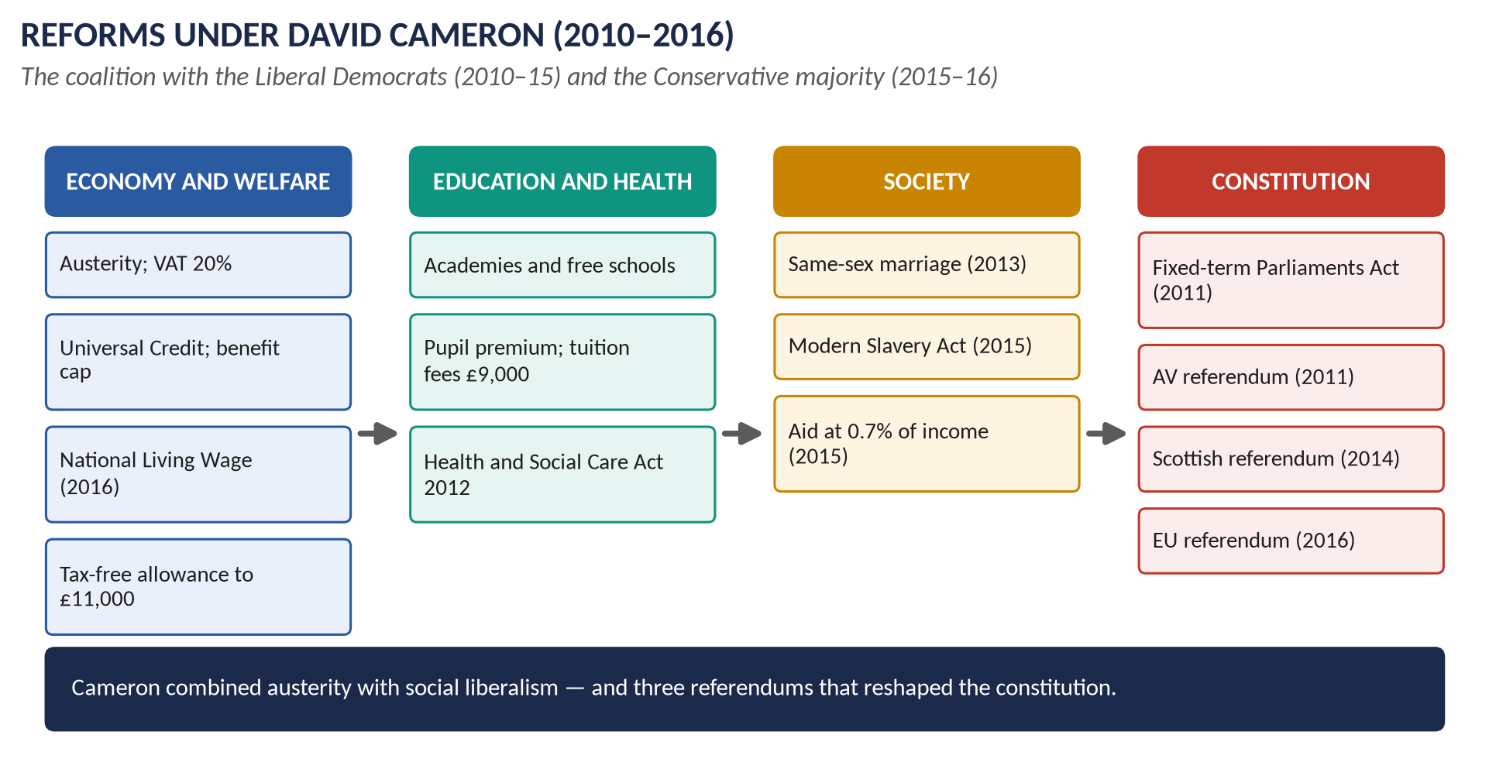
Figure 6 · Reforms under Cameron.

4.1 The coalition
- The 2010 election produced a hung parliament; after five days of talks the Conservatives and Liberal Democrats formed a coalition (11 May 2010): David Cameron PM, Nick Clegg Deputy PM.
- The Coalition Agreement: deficit reduction; a referendum on the Alternative Vote; fixed-term parliaments; Liberal Democrat priorities such as raising the tax-free allowance and the pupil premium.
- 2015: the Conservatives won a majority of 12; the Liberal Democrats collapsed (8 seats).

4.2 Reforms under Cameron

(i) Economy and welfare
- Austerity (Osborne): the emergency budget (June 2010); VAT to 20 per cent (January 2011); departmental cuts of about a fifth; public-sector pay freezes.
- Welfare Reform Act (2012): Universal Credit (merging six benefits); the benefit cap (2013); the "bedroom tax" (2013).
- The tax-free personal allowance raised from £6,475 to £11,000 (2016) — a Liberal Democrat policy.
- Pensions: the triple lock (2010–11); automatic enrolment in workplace pensions (2012); pension freedoms (2015).
- The National Living Wage (April 2016, £7.20 for over-25s).

(ii) Education
- The Academies Act (2010): most secondary schools became academies; free schools set up by parents and charities.
- Michael Gove's reforms: a tougher national curriculum; GCSEs graded 9–1; A-level reform.
- The pupil premium (2011): extra money for poorer pupils.
- University tuition fees up to £9,000 (2012) — breaking the Liberal Democrats' pledge.

(iii) Health
The Health and Social Care Act (2012, Andrew Lansley): GP-led clinical commissioning groups and more competition — controversial and later largely reversed.

(iv) Society
- Same-sex marriage (Marriage (Same Sex Couples) Act 2013; first weddings March 2014) — Cameron's proudest achievement.
- The Modern Slavery Act (2015).
- Overseas aid at 0.7 per cent of national income written into law (2015).
- The "Big Society": volunteering and community action.
- The Leveson Inquiry (2011–12) into press standards after phone hacking.
- Police and crime commissioners (2012).

(v) The constitution
- The Fixed-term Parliaments Act (2011).
- The Alternative Vote referendum (May 2011): rejected, 68 per cent No.
- The Scottish independence referendum (18 September 2014): 55.3 per cent No; more powers followed (Scotland Act 2016).
- English Votes for English Laws (2015); recall of MPs (2015).
- The EU referendum (23 June 2016) — which ended his premiership.

4.3 Cameron's foreign policy

(i) General features
- "Liberal conservatism": support for freedom and democracy, but cautious, practical, "not naive" after Iraq.
- Commercial diplomacy: trade missions; the "golden era" with China (Xi Jinping's state visit, October 2015).
- Aid: 0.7 per cent of national income.
- Defence: cuts in the 2010 review; a NATO 2 per cent pledge (2015).
- Russia: sanctions after the annexation of Crimea (2014).
- Europe: the Bloomberg speech (2013), renegotiation (2016), referendum.

(ii) The Middle East
1. The Arab Spring (2011): support for the uprisings.
2. Libya (March–October 2011): with France's Sarkozy, Cameron pushed for UN Resolution 1973; NATO air strikes protected civilians and helped rebels overthrow Gaddafi (killed October 2011). Libya then fell into chaos; the Commons Foreign Affairs Committee (2016) criticised the intervention's planning.
3. Syria: Cameron demanded that Assad go; after a chemical attack (Ghouta, August 2013) he sought support for strikes, but the Commons voted against (29 August 2013, 285 to 272) — the first time since 1782 a PM had lost a vote on war; Britain resettled Syrian refugees (20,000 pledged, 2015).
4. ISIS: air strikes in Iraq (from September 2014) and Syria (after a Commons vote, December 2015).
5. Iran: the nuclear deal (JCPOA, July 2015); the British embassy in Tehran reopened (August 2015).
6. The Gulf: close ties with Saudi Arabia (arms sales, criticised over the war in Yemen from 2015); a permanent naval base in Bahrain (agreed 2014).
7. Israel and Palestine: support for a two-state solution; he called Gaza a "prison camp" (2010); a non-binding Commons vote (2014) to recognise Palestine.
8. Afghanistan: combat operations ended (2014).
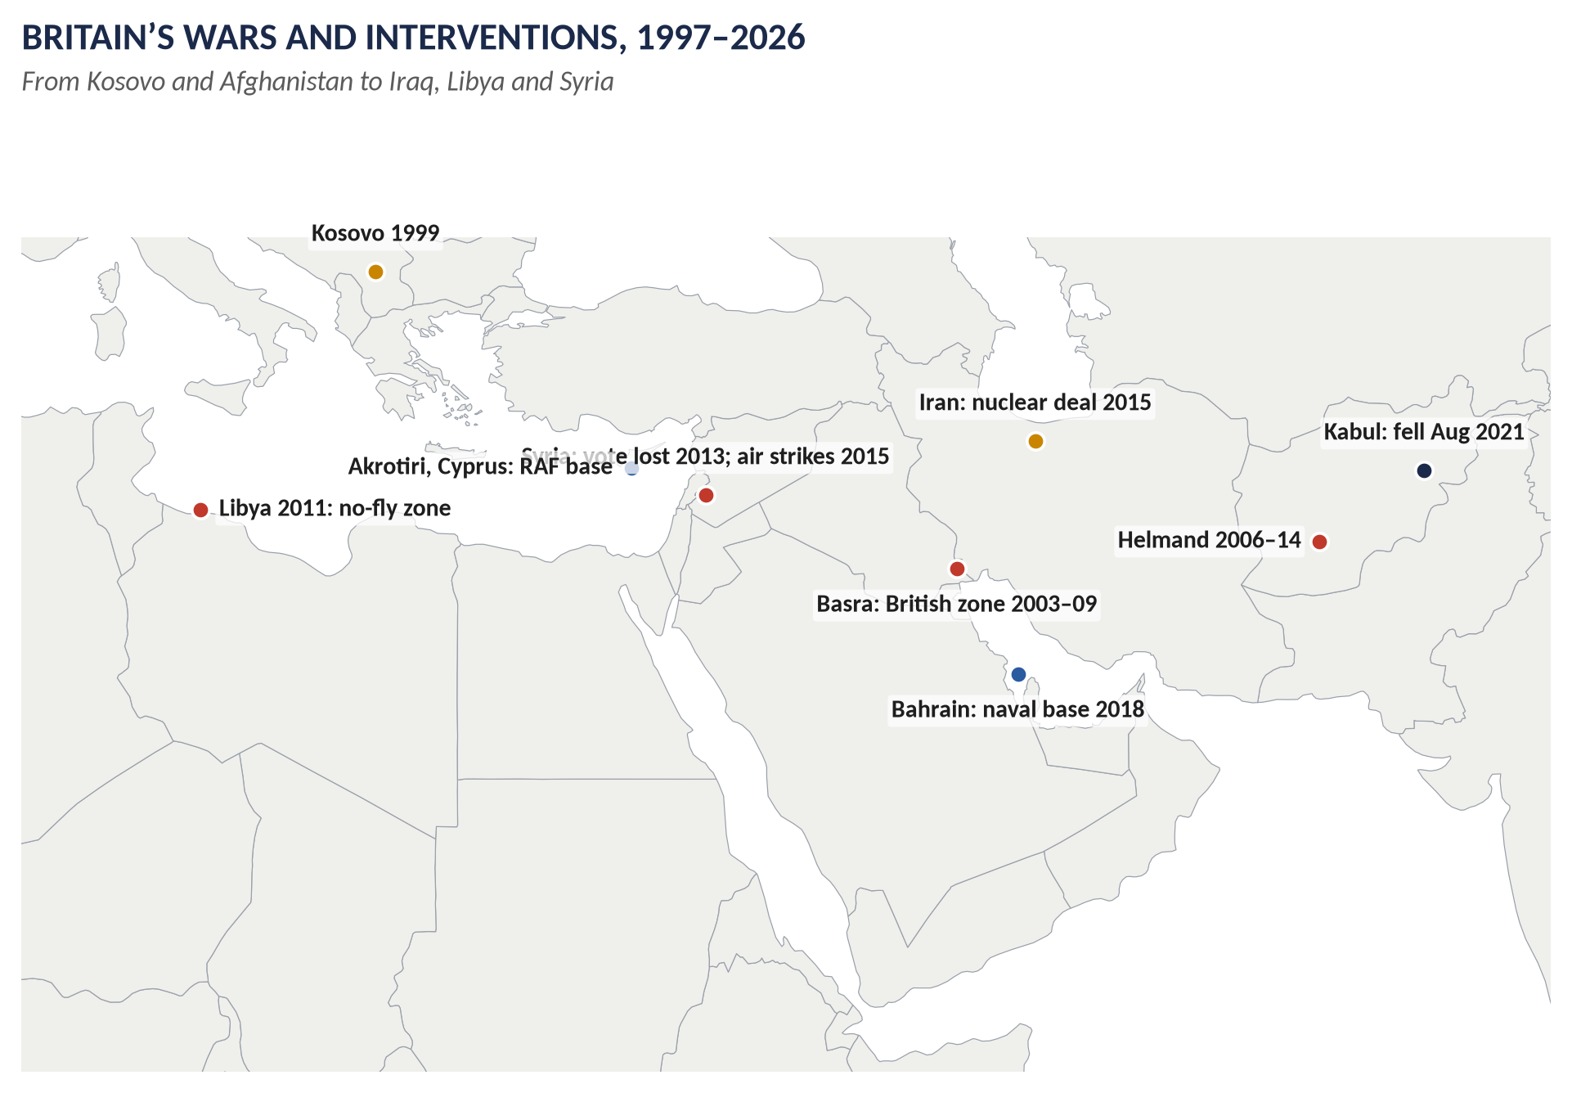
Figure 7 · Britain's interventions, 1997–2026.
WHAT THE EXAMINER HAS ASKED · Where Chapter 4 has been asked
2016 Q7 (Cameron's foreign policy, with reference to the Middle East) · 2024 Q7(b) and 2025 Q8(c) (short notes: reforms under Cameron). MCQs 2025: Cameron formed a coalition government in 2010; 2026: with the Liberal Democrats, led by Cameron.

Chapter 5 · Brexit (2016–2026)
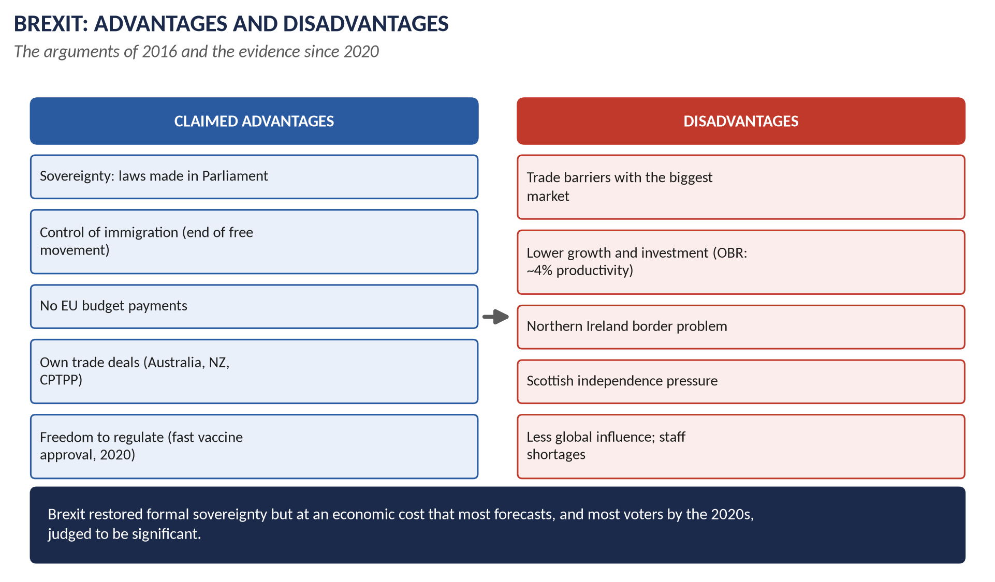
Figure 8 · Brexit: advantages and disadvantages.

5.1 The road to the referendum
Euroscepticism in the Conservative Party (Maastricht); UKIP's rise (first in the 2014 European elections); immigration after 2004; Cameron's Bloomberg speech (January 2013) promising a referendum; his renegotiation (February 2016).

5.2 The referendum (23 June 2016)
- Leave 51.9 per cent (17.4 million), Remain 48.1 per cent; turnout 72 per cent.
- England and Wales voted Leave; Scotland (62 per cent Remain) and Northern Ireland (56 per cent) voted Remain.
- Leave arguments: "Take Back Control" of laws, money and borders; £350 million a week for the NHS (a disputed figure).
- Remain arguments: the economy, jobs, security, influence.
- Cameron resigned.

5.3 Leaving (2016–2020)
- Theresa May (July 2016): Article 50 triggered (29 March 2017); lost her majority in the June 2017 election; her deal was defeated three times (2019, the first by 230 votes — the largest government defeat ever); she resigned.
- Boris Johnson (July 2019): a new deal (the Northern Ireland Protocol); "Get Brexit Done" — a majority of 80 (December 2019).
- Britain left on 31 January 2020; the Trade and Cooperation Agreement (24 December 2020) — tariff-free trade in goods, but new customs and regulatory barriers.
- The Windsor Framework (February 2023) eased the Northern Ireland Protocol.

5.4 Advantages and disadvantages — the arguments and the evidence
Area | Advantages (claimed and actual) | Disadvantages (claimed and actual)
Sovereignty | Laws made by Parliament; the EU Court no longer supreme | Must still follow EU rules to trade; less say in making them
Money | No annual net EU contribution (about £9–10 billion) | Lost EU funds for regions, farming, science (some replaced)
Trade | Own trade deals: Australia, New Zealand, CPTPP (joined 2024–25), India (2025) | New barriers with the EU (about 40% of trade); OBR: trade about 15% lower in the long run
The economy | Freedom to regulate (the fast approval of the Covid vaccine, December 2020) | OBR: productivity about 4 per cent lower in the long run; weaker investment
Immigration | End of free movement; a points-based system | Labour shortages (lorry drivers, care); net migration actually rose to record levels (about 900,000 in 2022–23)
Fishing and farming | Control of waters | Fishermen disappointed; export barriers
The Union | — | Northern Ireland border problem; stronger demand for Scottish independence
Influence | "Global Britain"; free to act (e.g. early support for Ukraine) | Less influence in Europe; weaker in Washington and Beijing
Culture and science | The Turing scheme | Left Erasmus; Horizon science rejoined only in 2024

5.5 Public opinion and the "reset"
- By the early 2020s most polls found a majority thought Brexit was the wrong decision.
- Starmer ruled out rejoining the single market or customs union but sought a "reset": the UK–EU summit (May 2025) agreed a security and defence partnership and talks on food and agricultural standards, youth mobility and energy.
WHAT THE EXAMINER HAS ASKED · Where Chapter 5 has been asked
2017 Q8 (advantages and disadvantages of Brexit).

Chapter 6 · Lady Diana (1961–1997)
- Born Diana Spencer on 1 July 1961 at Sandringham, daughter of Earl Spencer.
- Married Prince Charles on 29 July 1981 at St Paul's Cathedral — watched by about 750 million people worldwide.
- Sons: Prince William (1982) and Prince Harry (1984).
- Charity and humanitarian work:
  - HIV/AIDS — in 1987 she shook hands with an AIDS patient without gloves, challenging stigma.
  - Leprosy, homelessness, children's hospitals, cancer.
  - Landmines — she walked through a minefield in Angola (January 1997) and visited Bosnia; the Ottawa Treaty banning landmines was signed in December 1997.
- The marriage broke down: separation (1992); her BBC Panorama interview (November 1995): "There were three of us in this marriage"; divorce (August 1996).
- Death: killed in a car crash in the Pont de l'Alma tunnel, Paris, on 31 August 1997, with Dodi Fayed, pursued by photographers.
- "The People's Princess": Tony Blair's tribute; a huge outpouring of public grief; flowers outside Kensington Palace.
- The monarchy under pressure: the Queen was criticised for staying at Balmoral; she returned and spoke on television; the royal family became more open and informal.
- Funeral: 6 September 1997; Elton John's "Candle in the Wind 1997".
- Inquiries: Operation Paget (2006) and the inquest (2008): unlawful killing through the gross negligence of the driver and the pursuing paparazzi. The Dyson report (2021) found the BBC had used deceit to obtain the Panorama interview.
- Legacy: a modernised, more emotional public culture; her sons' charitable work; her place as a global icon.
WHAT THE EXAMINER HAS ASKED · Where Chapter 6 has been asked
2018 Q8(c) (short note: Lady Diana) · 2026 Q8(b) (short note: Lady Diana Spencer).

Chapter 7 · Britain since 2016

7.1 May, Johnson, Truss, Sunak
- Theresa May (2016–19): Brexit; the Grenfell Tower fire (June 2017, 72 dead); the Salisbury poisoning (2018).
- Boris Johnson (2019–22): Brexit done; Covid-19 — lockdowns (from March 2020), the successful vaccine programme (from December 2020), about 230,000 deaths; "partygate"; support for Ukraine after Russia's invasion (February 2022); resigned after ministerial resignations (July 2022).
- Liz Truss (September–October 2022): the "mini-budget" of unfunded tax cuts crashed the pound and gilt markets; she resigned after 49 days — the shortest premiership in British history.
- Rishi Sunak (October 2022 – July 2024): the first British Asian and Hindu Prime Minister; stabilised the finances; the Windsor Framework; the Rwanda asylum scheme.
- Queen Elizabeth II died on 8 September 2022; King Charles III (crowned 6 May 2023).

7.2 Starmer (2024–2026) and Burnham (2026–)
- 4 July 2024: Labour 411 seats on about 34 per cent of the vote; Conservatives 121; Liberal Democrats 72; Reform UK 5 seats but about 14 per cent of the vote.
- Policies: growth and planning reform; Great British Energy; public ownership of the railways (from 2025); workers' rights (the Employment Rights Bill); VAT on private-school fees (2025); a rise in employers' National Insurance (2025).
- Foreign: support for Ukraine and the "coalition of the willing"; defence spending to rise; the EU reset (2025); the Chagos agreement (2025); recognition of Palestine (September 2025).
- Foreign policy, 2025: the Chagos agreement with Mauritius (signed 22 May 2025; Diego Garcia leased back for 99 years); the UK–EU summit (May 2025); the UK–India trade agreement (signed 24 July 2025, in force July 2026); recognition of the State of Palestine (21 September 2025); defence spending to rise.
- Troubles: weak growth and tax rises; welfare U-turns (2025); the resignation of Deputy PM Angela Rayner over unpaid stamp duty (5 September 2025) and a major reshuffle — Lammy Deputy PM, Cooper Foreign Secretary, Mahmood Home Secretary; the rise of Reform UK in the polls and in the May 2025 local elections.
- The May 2026 elections (7 May): Labour lost about 1,500 councillors and control of 38 councils. In Scotland the SNP won 58 of 129 seats (short of a majority), with Reform UK and Labour on 17 each. In Wales — the first election to an enlarged, 96-member Senedd by proportional representation — Plaid Cymru won 43 seats and Reform UK 34; Labour's century of dominance in Wales ended, and Rhun ap Iorwerth became First Minister of a Plaid minority government.
- The fall of Starmer: a Labour leadership crisis followed; Andy Burnham, Mayor of Greater Manchester, won the Makerfield by-election (18 June 2026, about 55 per cent); Starmer announced his resignation (22 June 2026).
- Andy Burnham was elected Labour leader unopposed (17 July 2026) and became Prime Minister on 20 July 2026 — the fourth Labour PM since 1997 and the seventh PM in ten years.

Chapter 8 · 1997–2012: Renewal or Unresolved Contradictions?
Area | Renewal | Unresolved contradictions
Constitution | Devolution; the Good Friday Agreement; the Human Rights Act; FOI; Lords reform (1999); the Supreme Court (2009) | The "English question" (West Lothian); the SNP won power (2007) and a majority (2011) → the 2014 referendum; the HRA v anti-terror laws; Lords reform unfinished (the 2012 bill abandoned); AV rejected (2011)
Foreign policy | "Ethical dimension"; Kosovo; Sierra Leone; aid and debt relief; climate leadership | Iraq (an illegal war?); rendition and torture; Libya (2011); pro-European words but no euro; Lisbon without a referendum
Economy | Bank independence; long growth; minimum wage; public services rebuilt | Light regulation → the 2008 crash; debt; inequality; regional divides
Identity | "Cool Britannia"; a confident multicultural nation; civil partnerships; the London 2012 Olympics | The Britishness debate (Brown); 7/7 and home-grown terror; immigration after 2004; the rise of UKIP

Judgement: the period was a genuine renewal — Britain's constitution, public services, social attitudes and international profile were transformed — but it left contradictions (over sovereignty, Europe, the Union, liberty and security, and a debt-fuelled economy) that were papered over until 2012 and then broke open: the Scottish referendum (2014), the Brexit vote (2016) and a decade of turmoil.
WHAT THE EXAMINER HAS ASKED · Where Chapter 8 has been asked
2026 Q7 (1997–2012: renewal or unresolved contradictions?).

Part Four — Historians and Quotations
Writer | The view to quote
Anthony Giddens, The Third Way (1998) | The theory of New Labour.
Stuart Hall, "The Great Moving Nowhere Show" (1998) | New Labour as Thatcherism continued.
Anthony Seldon, Blair (2004) and later volumes | Blair's achievements and failures.
Andrew Rawnsley, The End of the Party (2010) | The Blair–Brown rivalry.
Sir John Chilcot, The Iraq Inquiry (2016) | The case against the Iraq decision.
Mark Blyth, Austerity (2013) | Austerity as "a dangerous idea".
Thiemo Fetzer (2019) | Austerity increased the Leave vote.
Vernon Bogdanor, The New British Constitution (2009) | The constitutional revolution after 1997.

"A new dawn has broken, has it not?" — Blair, 2 May 1997
"She was the People's Princess." — Blair, 31 August 1997
"We will find those who did it, we will smoke them out of their holes …" — George W. Bush, September 2001
"I will be with you, whatever." — Blair to Bush, July 2002 (Chilcot Report)
"We're all in this together." — George Osborne, 2009–10

Part Five — The Examiner's Record
Paper | The question as set | Family | Type
2016 · Q7 · Section B | Discuss the main features of the foreign policy of David Cameron with special reference to the Middle East. | David Cameron | Policy analysis
2017 · Q8 · Section B | What are the advantages and disadvantages of Brexit for England? Analyse with arguments. | Brexit | Impact / significance
2018 · Q8(c) · Section B | Short note: Lady Diana | Diana, Princess of Wales | Short note
2021 · Q8 · Section B | What were the salient features of Tony Blair's policy on the War on Terror? How did his policy affect US-Britain relations? | The War on Terror | Policy analysis
2023 · Q7 · Section B | 'We will find those who did it, we will smoke them out of their holes, we will get them running and we will bring them to justice.' In the context of this remark, present a balanced critique of the War on Terror with special emphasis on the role of Great Britain. | The War on Terror | Quotation / claim
2023 · Q8 · Section B | How did the global financial crisis plunge Britain into recession in the 21st century and how did it respond? | The 2008 financial crisis | Causes / results
2024 · Q7(b) · Section B | Short note: Reforms under David Cameron | David Cameron | Short note
2025 · Q6 · Section B | How did the policies of New Labour under Tony Blair differ from those of previous Labour governments? Was it a continuation of Thatcherism by other means, or did it represent a distinct political project? | Blair and New Labour | How far / extent
2025 · Q7 · Section B | How did the global financial crisis of 2008 impact British politics and society? How did the responses of the Labour and Conservative governments differ, and what were their long-term effects? | The 2008 financial crisis | Impact / significance
2025 · Q8(c) · Section B | Short note: Reforms under Cameron Government | David Cameron | Short note
2026 · Q7 · Section B | From 1997 to 2012, Britain saw dramatic shifts in foreign policy, constitutional reform and international identity. Assess whether the period should be interpreted as one of renewal or of unresolved contradictions in British governance. | Blair and New Labour | How far / extent
2026 · Q8(a) · Section B | Short note: Britain's role in the War on Terror | The War on Terror | Short note
2026 · Q8(b) · Section B | Short note: Lady Diana Spencer | Diana, Princess of Wales | Short note

WHAT THE EXAMINER HAS ASKED · The pattern
The War on Terror (2021: Blair's policy and US relations; 2023: a critique with Bush's words; 2026 short note). New Labour (2025: v Old Labour and Thatcherism; 2026: renewal or contradictions 1997–2012). The financial crisis (2023: recession and response; 2025: impact, the two responses, long-term effects). Cameron (2016: foreign policy in the Middle East; short notes on his reforms 2024, 2025). Brexit (2017). Diana (short notes 2018, 2026). Not yet set: devolution and the Good Friday Agreement as full questions, May and Johnson, Covid, Starmer.

Part Six — The One-Liner Bank
HOW TO USE THIS · How to use the one-liners
Cover the answer after the arrow and say it aloud. 120 questions; bold words are the ones examiners test. The past MCQs are solved in T10QA.

One-liners · New Labour
1. Which party governed under Tony Blair? → The Labour Party.
2. When did Blair win his first election? → 1 May 1997.
3. How many seats did Labour win in 1997? → 418.
4. When did Blair rewrite Clause IV? → 1995.
5. Who wrote The Third Way (1998)? → Anthony Giddens.
6. What did Blair say were his three priorities? → "Education, education, education".
7. What did Brown give the Bank of England in May 1997? → Independence to set interest rates.
8. When did the minimum wage begin? → April 1999 (£3.60 an hour).
9. What was Sure Start (1998)? → Children's centres for families in poor areas.
10. What did Labour pledge on child poverty (1999)? → To halve it by 2010 and end it by 2020.
11. When were tuition fees first introduced? → 1998 (£1,000).
12. What new type of school did Labour create in 2000? → Academies.
13. When did the Scottish Parliament and Welsh Assembly open? → 1999.
14. When was the Good Friday Agreement signed? → 10 April 1998.
15. Which conflict did it address? → Northern Ireland.
16. Which US senator chaired the talks? → George Mitchell.
17. Which Act (1998) brought the ECHR into UK law? → The Human Rights Act.
18. How many hereditary peers stayed after 1999? → 92.
19. Which Act (2000) gave a right to official information? → The Freedom of Information Act.
20. When did the Supreme Court open? → 2009.
21. When were civil partnerships introduced? → 2004.
22. Who promised an "ethical dimension" to foreign policy? → Robin Cook (1997).
23. What did Blair's Chicago speech (1999) set out? → The "doctrine of the international community".
24. Which 2000 intervention saved Sierra Leone's capital? → Operation Palliser.
25. Which 2005 summit focused on Africa and climate? → Gleneagles G8.
26. Who called New Labour her "greatest achievement"? → Margaret Thatcher.
27. Who called New Labour "the great moving nowhere show"? → Stuart Hall.
28. When did Gordon Brown become PM? → June 2007.
29. Which 2008 Act set legal carbon targets? → The Climate Change Act.
30. What scandal broke in May 2009? → The MPs' expenses scandal.

One-liners · The War on Terror
31. When were the 9/11 attacks? → 11 September 2001.
32. Which group carried them out? → Al-Qaeda.
33. What did Blair promise the USA? → To stand "shoulder to shoulder".
34. Who said "we will smoke them out of their holes"? → George W. Bush (September 2001).
35. When did the war in Afghanistan begin? → October 2001.
36. Which government sheltered bin Laden? → The Taliban.
37. Which Afghan province did British forces take over in 2006? → Helmand.
38. How many British servicemen died in Afghanistan? → 457.
39. When did British combat operations in Afghanistan end? → 2014.
40. When did the Taliban retake Kabul? → August 2021.
41. When was bin Laden killed? → May 2011.
42. Which PM sent British troops to Iraq in 2003? → Tony Blair.
43. What was Iraq said to possess? → Weapons of mass destruction.
44. What claim in the September 2002 dossier became notorious? → WMD ready "within 45 minutes".
45. Which UN resolution (Nov 2002) gave Iraq a "final opportunity"? → Resolution 1441.
46. How many marched against the war in London (Feb 2003)? → About 1 million.
47. Which minister resigned over Iraq? → Robin Cook.
48. When did the invasion begin? → 20 March 2003.
49. Which Iraqi city did British forces hold? → Basra.
50. How many British servicemen died in Iraq? → 179.
51. Which weapons expert died in July 2003? → Dr David Kelly.
52. Which report (2016) judged the Iraq decision? → The Chilcot Report.
53. When were the 7/7 London bombings? → 7 July 2005.
54. How many people did they kill? → 52.
55. Which strategy aims to stop radicalisation? → Prevent.
56. What was Blair's first Commons defeat (2005)? → 90-day detention without charge.
57. What nickname did critics give Blair? → "Bush's poodle".
58. Which terrorist group arose from the chaos in Iraq and Syria? → ISIS (Islamic State).

One-liners · The financial crisis
59. What is the 2008 downturn called? → The (global) Financial Crisis.
60. Which bank suffered Britain's first run in 150 years (2007)? → Northern Rock.
61. Which US bank collapsed in September 2008? → Lehman Brothers.
62. When was the great bank rescue? → 8 October 2008.
63. Which banks did the state part-own? → RBS and Lloyds.
64. To what level was Bank Rate cut in March 2009? → 0.5 per cent.
65. What is quantitative easing? → The Bank of England creating money to buy bonds.
66. To what was VAT cut in December 2008? → 15 per cent.
67. Where was the G20 summit of April 2009? → London.
68. By how much did GDP fall in the recession? → About 6 per cent.
69. Who was Labour's Chancellor during the crisis? → Alistair Darling.
70. Who was the coalition's Chancellor? → George Osborne.
71. What was the coalition's economic policy called? → Austerity.
72. To what did the coalition raise VAT (2011)? → 20 per cent.
73. Which report recommended bank ring-fencing? → The Vickers report (2011).
74. Which two bodies replaced the FSA (2013)? → The PRA and the FCA.
75. What did Osborne say about austerity? → "We're all in this together."
76. What charity's food-bank use soared after 2008? → The Trussell Trust.

One-liners · Cameron
77. What type of government did Cameron form in 2010? → A coalition government.
78. With which party? → The Liberal Democrats.
79. Who led the 2010–15 coalition? → David Cameron (Clegg was deputy).
80. What was Nick Clegg's post? → Deputy Prime Minister.
81. Which benefit merged six others? → Universal Credit.
82. Which Act (2012) created it? → The Welfare Reform Act.
83. To what did tuition fees rise in 2012? → £9,000.
84. What extra money did poorer pupils get from 2011? → The pupil premium.
85. Which Act (2013) allowed same-sex marriage? → The Marriage (Same Sex Couples) Act.
86. Which Act of 2015 targeted modern slavery? → The Modern Slavery Act.
87. What aid target was written into law (2015)? → 0.7 per cent of national income.
88. What was introduced in April 2016 for over-25s? → The National Living Wage.
89. Which Act (2011) fixed five-year parliaments? → The Fixed-term Parliaments Act.
90. What was the result of the AV referendum (2011)? → No (about 68 per cent).
91. What was the Scottish referendum result (2014)? → 55.3 per cent No.
92. Which UN resolution (2011) authorised action in Libya? → Resolution 1973.
93. When did the Commons reject strikes on Syria? → 29 August 2013.
94. When did Britain begin air strikes on ISIS in Syria? → December 2015.
95. Which deal with Iran (2015) did Cameron support? → The nuclear deal (JCPOA).
96. What did Cameron call relations with China? → A "golden era".
97. What was Cameron's vision of community action? → The "Big Society".

One-liners · Brexit and after
98. When was the EU referendum? → 23 June 2016.
99. What percentage voted Leave? → 51.9 per cent.
100. What was the Leave slogan? → "Take Back Control".
101. Which nations voted Remain? → Scotland and Northern Ireland.
102. Who succeeded Cameron? → Theresa May.
103. When was Article 50 triggered? → 29 March 2017.
104. By how much was May's deal first defeated? → 230 votes.
105. What was Johnson's slogan in 2019? → "Get Brexit Done".
106. When did Britain leave the EU? → 31 January 2020.
107. Which agreement (2023) eased the Northern Ireland Protocol? → The Windsor Framework.
108. Which Pacific trade bloc did Britain join? → The CPTPP.
109. Who was the shortest-serving PM (49 days)? → Liz Truss (2022).
110. Who was the first British Asian PM? → Rishi Sunak.
111. When did Elizabeth II die? → 8 September 2022.
112. How many seats did Labour win in 2024? → 411.
113. Who succeeded Starmer as Prime Minister in July 2026? → Andy Burnham.

One-liners · Diana
114. When was Diana Spencer born? → 1 July 1961.
115. When did she marry Prince Charles? → 29 July 1981.
116. Which weapons did she campaign against in 1997? → Landmines.
117. Which disease's stigma did she challenge (1987)? → HIV/AIDS.
118. What did she say in her 1995 Panorama interview? → "There were three of us in this marriage."
119. When and where did she die? → 31 August 1997, Paris.
120. What did Blair call her? → "The People's Princess".

Part Seven — Revision Sheet · Topic 10: Blair to Burnham
HOW TO USE THIS · How to use this sheet
Complete on its own for the night before the paper. Asked: War on Terror (2021, 2023, 2026 sn), New Labour (2025, 2026), financial crisis (2023, 2025), Cameron (2016; reforms sn 2024, 2025), Brexit (2017), Diana (sn 2018, 2026).

R10.1 New Labour
Making: four defeats; Kinnock, Smith; Blair leader 1994; Clause IV 1995; Third Way (Giddens). Elections: 1997 (418), 2001 (413), 2005 (355). Economy: Bank of England independence 1997; prudence; low income tax; windfall tax, New Deal; long boom; light regulation; PFI. Social: minimum wage 1999; tax credits; child-poverty pledge; Sure Start 1998; NHS spending doubled; academies 2000; tuition fees 1998/2004; civil partnerships 2004; Equality Act 2010. Constitution: devolution 1999; Good Friday Agreement 10 April 1998; HRA 1998; Lords Act 1999 (92); FOI 2000; London Mayor 2000; Supreme Court 2009. Foreign: ethical dimension (Cook); Kosovo 1999, Chicago speech; Sierra Leone 2000; DfID; Gleneagles 2005; Social Chapter; St Malo; no euro. Brown 2007–10: crisis; Climate Change Act 2008; expenses 2009. v Old Labour: no nationalisation; unions at arm's length; low tax; business. v Thatcherism: kept markets, union laws, low income tax — but minimum wage, tax credits, investment, constitution. Verdict: a distinct project on Thatcherite foundations (Hall: "moving nowhere"; Thatcher: "greatest achievement").

R10.2 The War on Terror
9/11 (11 Sept 2001; ~3,000 dead); Bush: "smoke them out"; Blair "shoulder to shoulder". Afghanistan: Oct 2001; Helmand 2006; 457 British dead; combat ended 2014; Taliban back Aug 2021; bin Laden killed 2011. Iraq: WMD; dossiers (45 minutes; "dodgy"); Res. 1441; 1m march (15 Feb 2003); Commons 412–149, 139 Labour rebels; Cook resigns; invasion 20 March 2003; ~46,000 troops; no WMD; Basra to 2009; 179 dead; Kelly; Hutton, Butler; Chilcot 2016 ("I will be with you, whatever"). Home: Terrorism Act 2000; ATCSA 2001 (Belmarsh; Lords 2004); control orders 2005; 90 days defeated 2005; 7/7 2005 (52 dead); Prevent. US relations: closest since 1945; influence (UN route, road map); "poodle"; Europe split; later Iraq syndrome (Syria 2013). Critique: al-Qaeda weakened, plots foiled v Iraq false case, huge deaths, ISIS, Taliban return, torture and rendition, more terror at home.

R10.3 The financial crisis
Causes: US sub-prime; securitisation; UK banks' huge balance sheets; light regulation. UK: Northern Rock run Sept 2007 (nationalised Feb 2008); Lehman 15 Sept 2008; Lloyds–HBOS; rescue 8 Oct 2008 (~£500bn; RBS, Lloyds); rates 0.5% (Mar 2009); QE (£375bn by 2012); VAT 15%; G20 London Apr 2009. Recession: GDP −6%; unemployment ~2.5–2.7m; borrowing ~10% GDP. Labour (Brown, Darling): Keynesian stimulus, rescue, 50p tax. Coalition (Cameron, Osborne): austerity, VAT 20%, cuts, welfare reform, Universal Credit; bank reform (Vickers ring-fencing; PRA/FCA 2013). Impact: Labour defeat 2010; coalition; distrust; protests; riots 2011; UKIP; wage stagnation; food banks; inequality. Long-term: productivity puzzle; QE and asset prices; strained services; high debt; safer banks; Brexit and populism.

R10.4 Cameron
Coalition with Liberal Democrats (Clegg) 11 May 2010; majority 2015. Reforms: austerity; Universal Credit (2012), benefit cap; allowance to £11,000; triple lock; auto-enrolment; National Living Wage 2016; academies and free schools; Gove curriculum; pupil premium; fees £9,000; Health and Social Care Act 2012; same-sex marriage 2013; Modern Slavery Act 2015; 0.7% aid law; Big Society; Leveson; Fixed-term Parliaments 2011; AV referendum 2011 (No); Scottish referendum 2014 (55.3% No); EVEL; EU referendum 2016. Foreign: liberal conservatism; China "golden era"; Russia sanctions; Middle East — Libya 2011 (Res. 1973; Gaddafi; chaos); Syria (vote lost 29 Aug 2013; refugees; strikes Dec 2015); ISIS strikes 2014–15; Iran deal 2015; Saudi arms; Bahrain base; Palestine vote 2014; Afghanistan ended 2014.

R10.5 Brexit
Referendum 23 June 2016: 51.9% Leave; Scotland, NI Remain; "Take Back Control". May: Article 50 (29 Mar 2017); 2017 election; deal defeated by 230. Johnson: majority 80 (Dec 2019); left 31 Jan 2020; TCA; Windsor Framework 2023. Advantages: sovereignty, no EU contributions, own trade deals (Australia, NZ, CPTPP, India), regulatory freedom (vaccine), end of free movement. Disadvantages: trade barriers (OBR: trade −15%, productivity −4%), investment, labour shortages, record net migration anyway, NI and Scotland, lost influence, Erasmus. Opinion turned; 2025 reset.

R10.6 Diana
Born 1 July 1961; married Charles 29 July 1981 (750m viewers); William 1982, Harry 1984; AIDS (1987), leprosy, homeless, landmines (Angola Jan 1997; Ottawa Treaty Dec 1997); separation 1992; Panorama 1995 ("three of us"); divorce 1996; died 31 Aug 1997, Paris; "People's Princess" (Blair); grief; the Queen criticised; funeral 6 Sept; inquest 2008 (unlawful killing — driver and paparazzi); Dyson 2021.

R10.7 Since 2016 and the big question
May (Grenfell); Johnson (Covid, vaccines, partygate, Ukraine); Truss 49 days; Sunak first British Asian PM; Elizabeth II d. 8 Sept 2022; Starmer 4 July 2024 (411); Chagos, India deal, EU reset, Palestine recognised (2025); Rayner resigns (Sept 2025); May 2026: Labour routed, Plaid governs Wales, SNP largest in Scotland, Reform surges; Burnham wins Makerfield (June), PM 20 July 2026. 1997–2012: renewal or contradictions? Renewal: constitution, peace, rights, services, aid, Cool Britannia, London 2012. Contradictions: English question and SNP; HRA v terror laws; Iraq; Europe without the euro; debt-fuelled boom → crash; Britishness, 7/7, immigration. Verdict: real renewal whose contradictions exploded after 2012 (Scotland 2014, Brexit 2016).
VERDICT · The whole topic in one sentence
New Labour renewed Britain's public services and constitution but tied it to America's wars and a fragile financial boom; the crash brought austerity, the austerity years brought Brexit, and Brexit brought a decade of turmoil that ended with Labour back in power in 2024.

